Problem1
1.1
On each event , I modify the code recon.C to run 100 minuit method with starting points randomly distributed. In each event, I store the theta and phi value with the minimum chi2 value. Finally, I dump the event into the 2D histogram to draw a skymap.
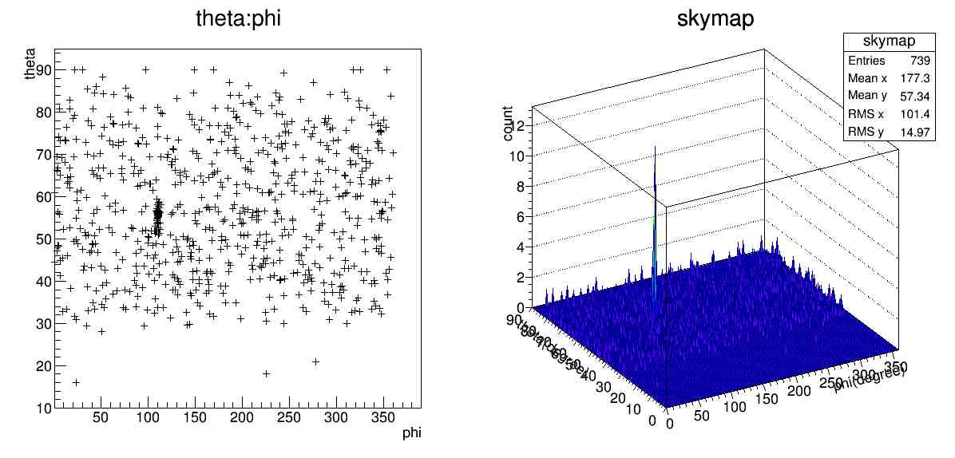
1.2
By the 2D histogram skymap(which is slice into 1 degree in both theta and phi), we can obtain the maximum number is 12 at (theta:phi) = (56, 111). We can alse found this property by the 1D histogram of theta and phi. The source is statistically enhanced.
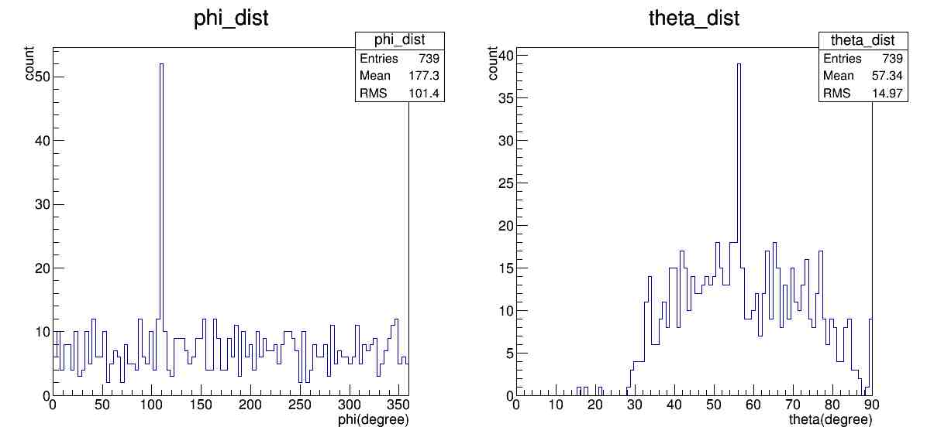
We can also found that the distribution over phi is quite uniform but the distribution over theta is not so uniform. It's clear that there's almost no event in 0 – 30 degree. Furthermore, if the theta = 90 means the zenith point and the evt distribution is uniform, the distribution will decrease due to the property of the spherical coordinate. From this to reasons, I think the theta here is the elevation angle not the zenith angle.
1.3
Based on the observation in 1.2, I defined the signal centered at 110, 55, with width 10 degrees. And I assume the background in the signal box is similar to the background near the signal box. So I use the background behavior of the neighborhood to estimate that in the signal box. Due the distribution is not uniform over theta but is uniform over phi. So I defined a box with the same size and theta- range as signal box moving degree by degree from phi = 0 to 360 except for the region of signal box. In each step, I obtain the number of event inside the box. The result shows that the mean of background box is 3.41349 and the standard deviation as uncertainty is 1.89821.
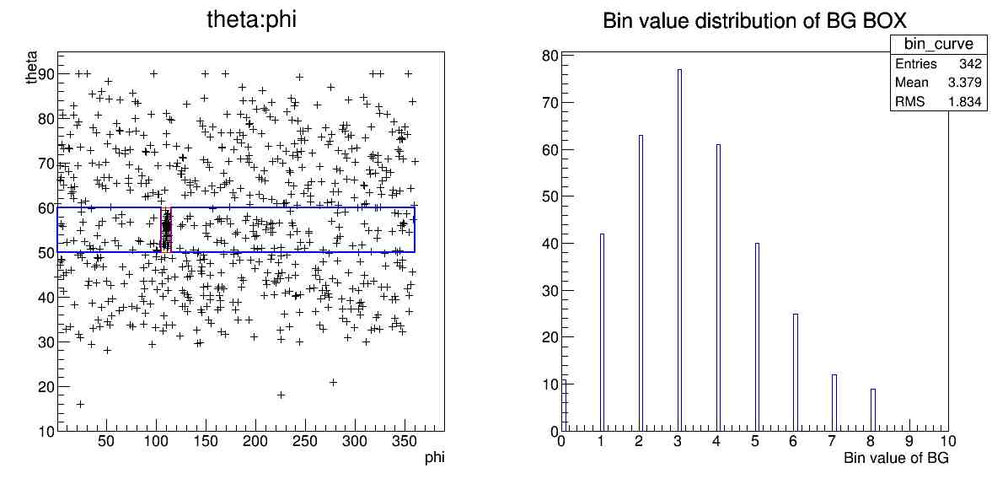
1.4
From the uncertainty and mean of the same size BG box in the same theta range, we can calculate the signal in the signal box. The total event in the signal box is 55, so the number of signal is 51.6 with a uncertainty 1.89821

Problem2
2.1
I modify the code to generate 1000 events for each theta with energy randomly distribute from 100GeV – 10000GeV to find the n_mu-Energy relationship in each zenith angle from 0 – 60 degree. The following are the in the theta = 0, 15, 30, 45, 60 degree(zenith angle).
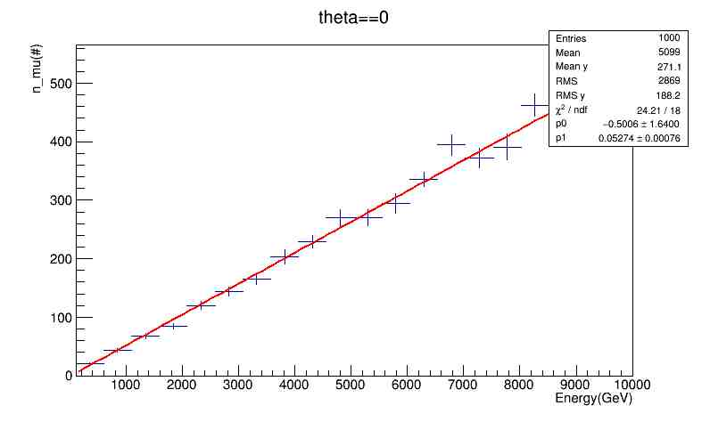
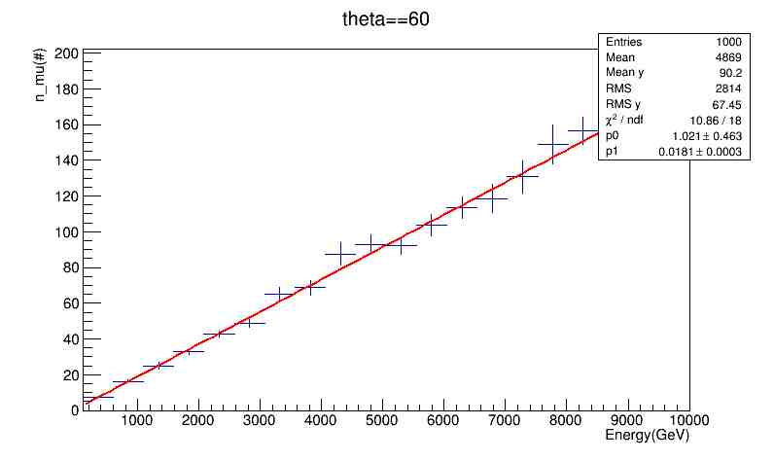
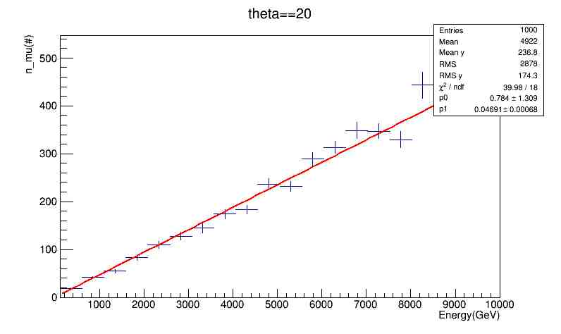
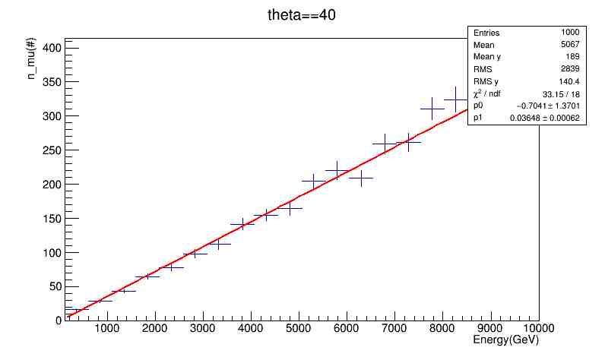
And I fill the parameters A and B of the equation N = A+BE in the ntuple, the following is the relationship between A and theta, B and theta.
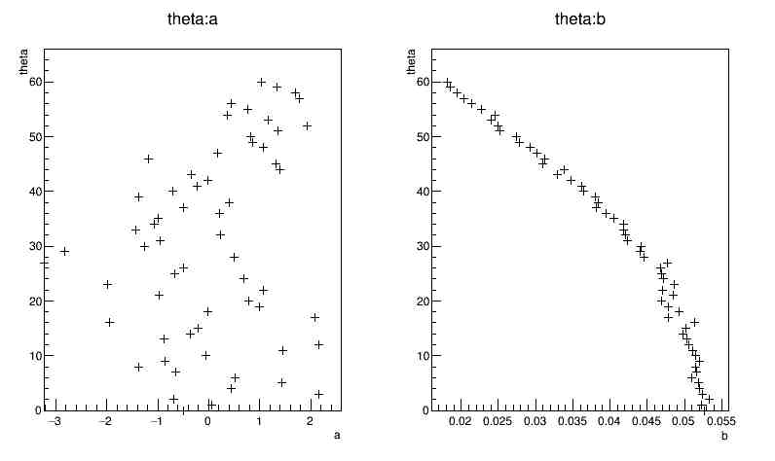
Program of this problem is in the problem2 folder, you can run the interaction_press.C to perform the simulation and it'll generate a tree contain the data. To show the result above, you can run energy_fit.C. It'll automatically generate the fitting result in the folder “result”.
2.2&2.3
the energy distribution of the background and the signal box at theta range from 50-60 degree(elevation angle) are shown below. The left one is the energy distribution of background and right one is the energy distribution inside the signal box.
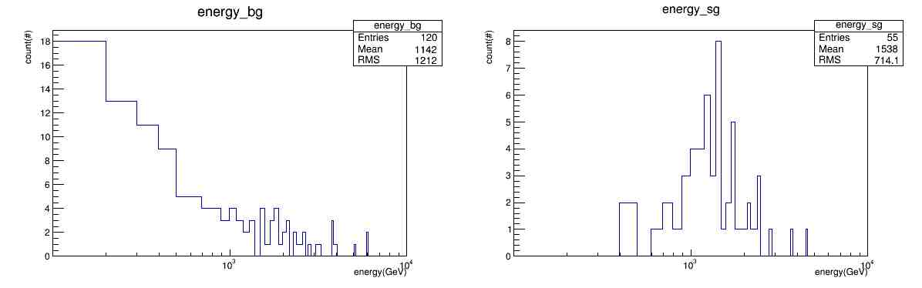
From problem 1.3 and 1.4 we obtain that the background is about 3.41349 and the total number of background in this theta range is 120, so the scale factor for background distribution is 3.41349/120.
With the scaled background distribution, the energy distribution of the source is the distribution of signal box minus that of the scaled background. The result show below, where I only draw the positive part. The left one is the scaled energy distribution of background inside the signal box, the right one is the scaled signal distribution inside the signal box.
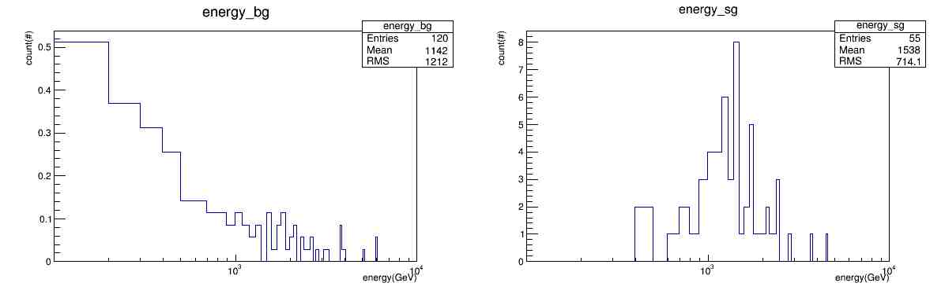
To perform the result, you can run recon2.C to get the reconstructed energy for each event. And use get_energy.C to draw the histogram above. The result will automatically generated to the folder.

